APP SERVER AND WEB SERVER.

1) Install nginx and run nginx on port number 81.

2) Deploy a sample index.html file on nginx.

3) Install Apache and run Apache on port number 82

4) Deploy a sample index.html file on Apache.

5) Install Apache tomcat on port number 8082

6) Deploy a sample app on webapps

7) Create a tomcat.service file for tomcat.

8) Configure HA Proxy server

1) Install nginx and run nginx on port number 81.

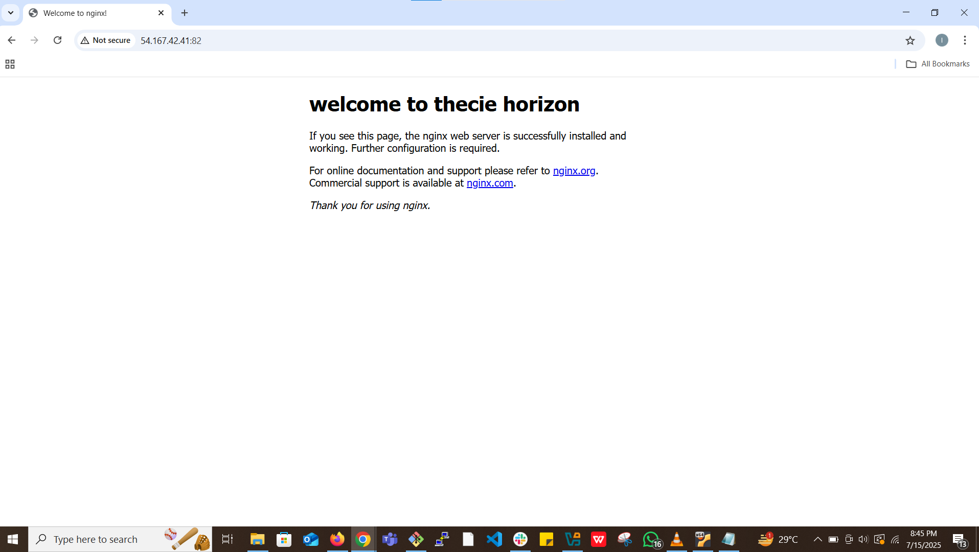

2) Deploy a sample index.html file on nginx.



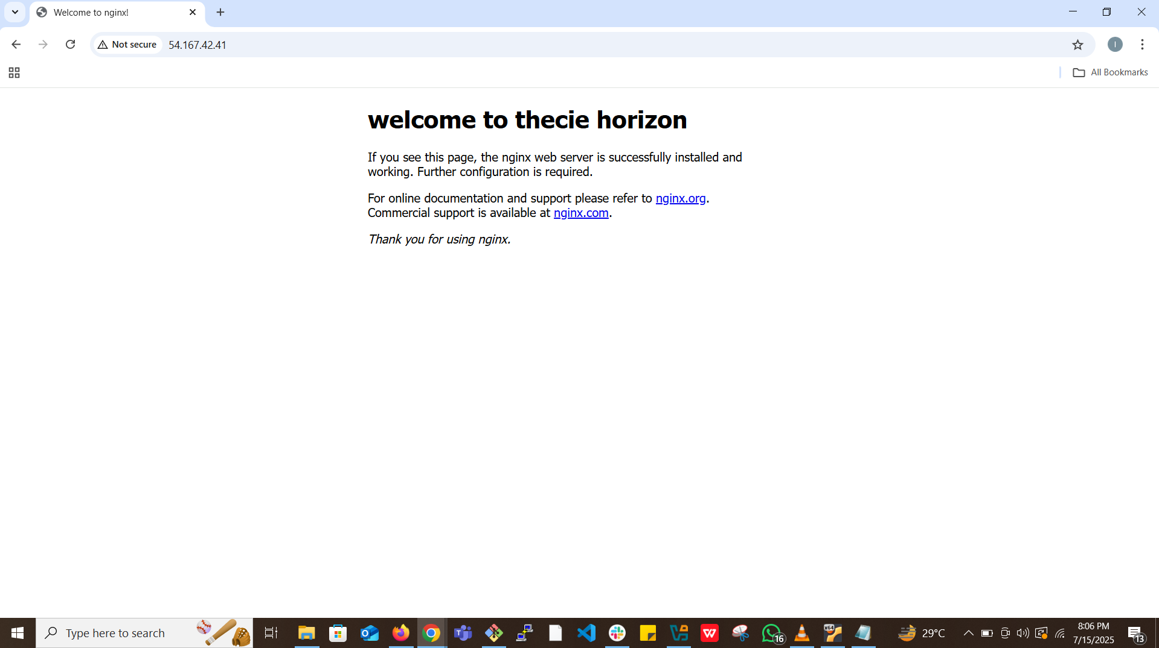

3) Install Apache and run Apache on port number 82

APACHE



APACHE at PORT 81



4) Deploy a sample index.html file on Apache.

before

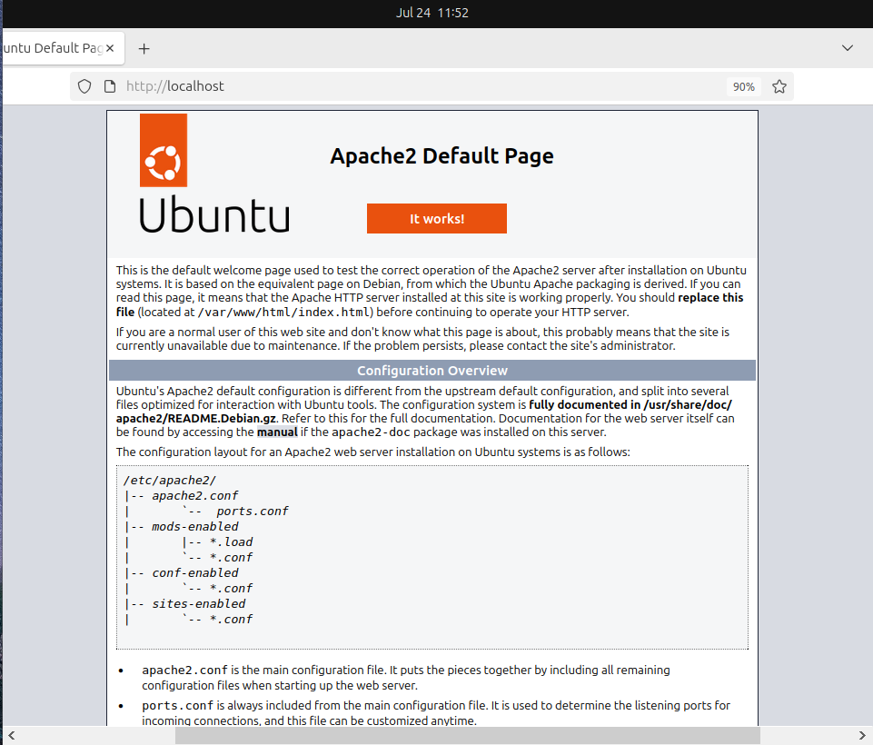

After

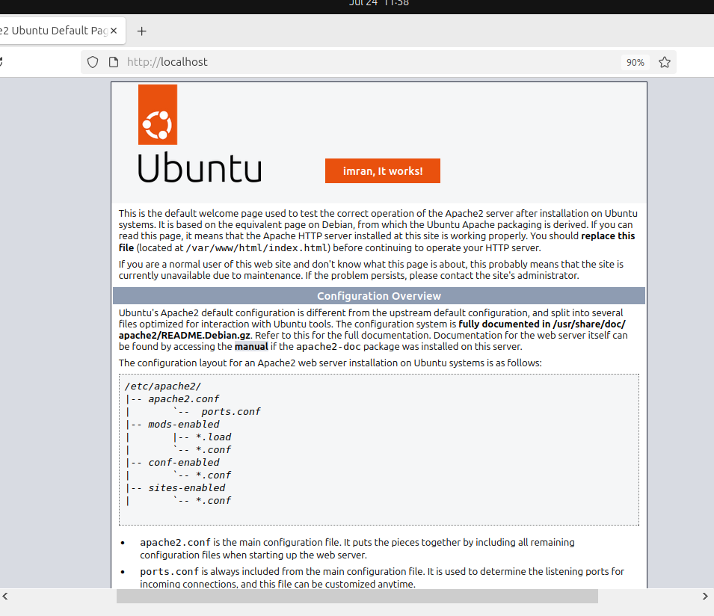

5) Install Apache tomcat on port number 8082

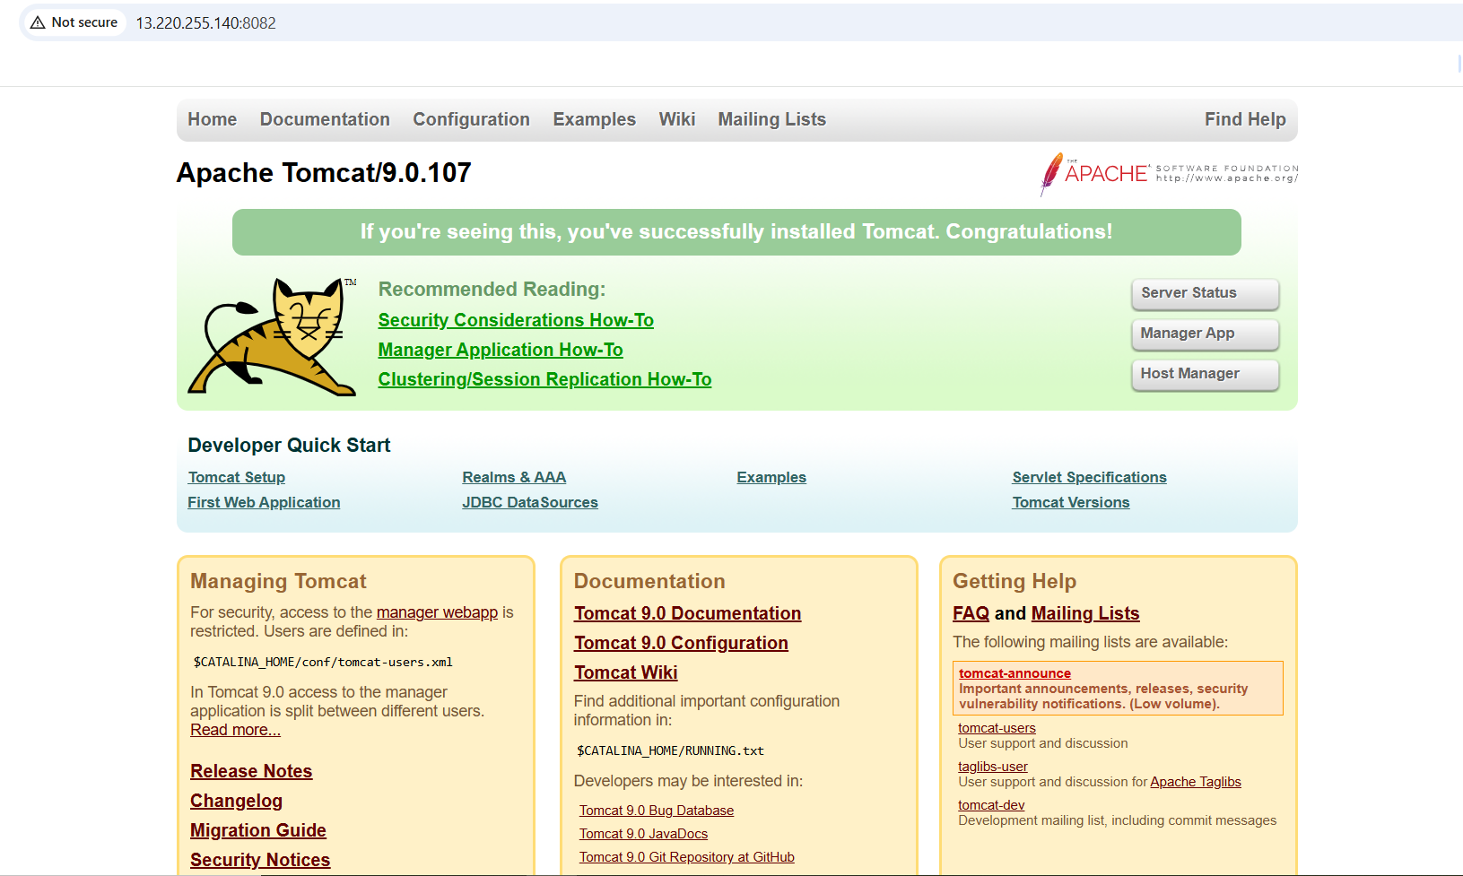

6) Deploy a sample app on webapps

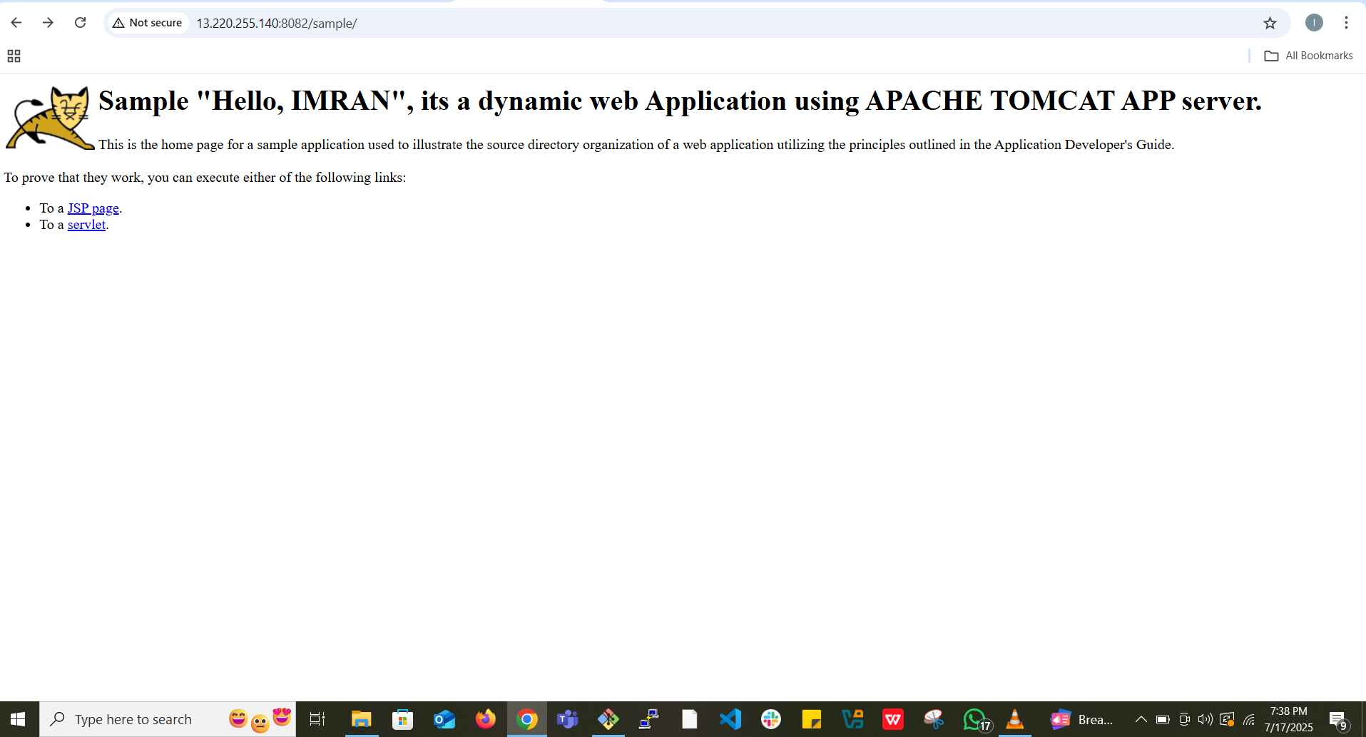

7) Create a tomcat.service file for tomcat.

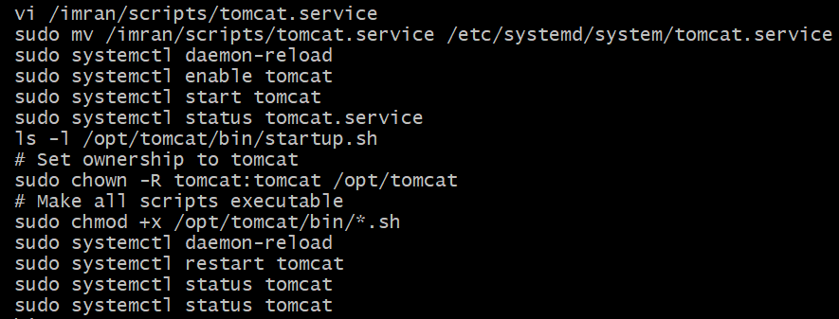

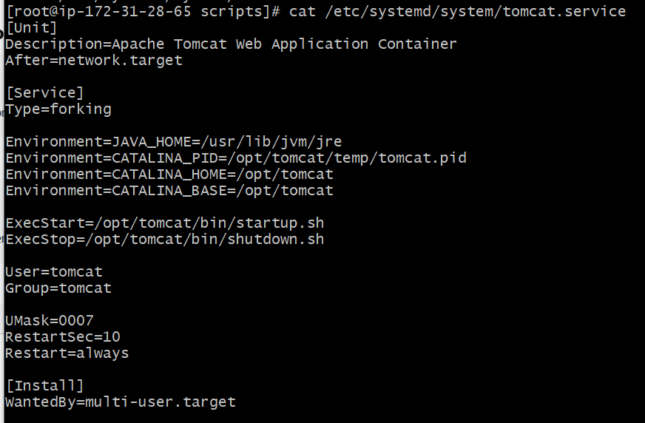

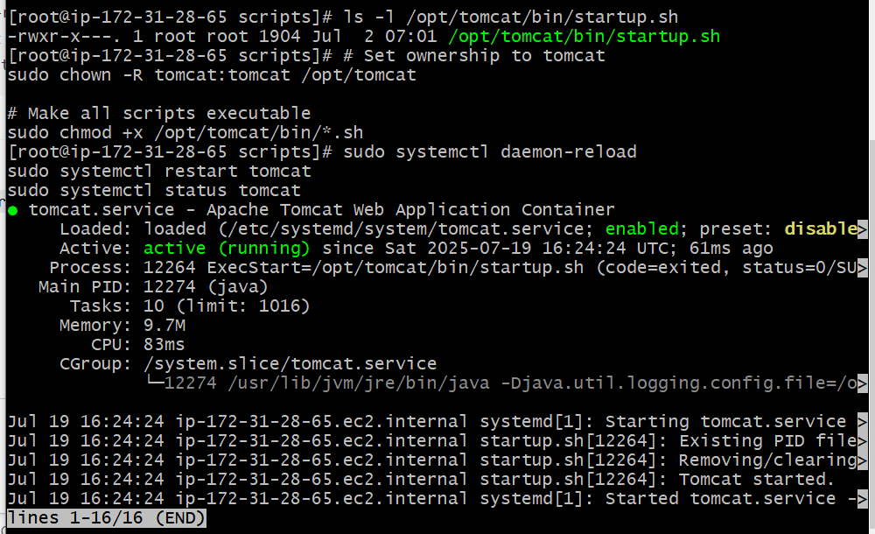

8) Configure HA Proxy server



